**A MULTIPERSPECTIVE FRAUD DETECTION METHOD FOR MULTI-PARTICIPANT E-COMMERCE TRANSACTIONS**

|  |
| --- |
| **CONTENT** |
| **Abstract** |
| **1.INTRODUCTION** |
| 1.1 Motivation |
| 1.2 Problem Statement |
| 1.3 Objective of the Project |
| 1.4 Scope |
| 1.5 Project Introduction |
| **2.LITERATURE SURVEY** |
| 2.1 Related Work |
| **3. SYSTEM ANALYSIS** |
| 3.1 Existing System |
| 3.2 Disadvantages |
| 3.3 Proposed System |
| 3.4 Advantages |
| 3.5 work Flow of Proposed system |
| **4. REQUIREMENT ANALYSIS** |
| 4.1Function and non-functional requirements |
| 4.2 Hardware Requirements |
| 4.3 Software Requirements |
| 4.4 Architecture |
| **5. METHODOLOGY** |
| 5.1 BI-LSTM |
| **6. SYSTEM DESIGN** |
| 6.1 Introduction of Input design |
| 6.2 UML Diagram(class, use case, sequence, collaborative, deployment, activity, ER diagram and Component diagram) |
| 6.3 Data Flow Diagram |
| **7. IMPLEMENTATION AND RESULTS** |
| 7.1 Modules |
| 7.2 Output Screens |
| **8.SYSTEM STUDY AND TESTING** |
| 9.1 Feasibility study |
| 9.2 Types of test & Test Cases |
| **10. CONCLUSION** |
| **11. FUTURE ENHANCEMENT** |
| **12. REFERENCES** |

**ABSTRACT**

In the realm of e-commerce, where transactions involve multiple participants such as buyers, sellers, and intermediaries, the detection of fraudulent activities presents a significant challenge. To address this issue, our proposed method focuses on a Mult perspective approach aimed at enhancing fraud detection accuracy and efficiency. The first step involves the detection of user behaviors, wherein we leverage various techniques such as behavioral analysis and examination of transaction histories to gain insights into normal user behavior patterns. By understanding typical user interactions within the e-commerce ecosystem, we establish a baseline against which abnormal behaviors can be identified. Subsequently, we delve into the analysis of abnormalities for feature extraction. Utilizing sophisticated anomaly detection algorithms, we scrutinize transaction data to uncover irregular patterns indicative of potentially fraudulent activities. This process allows us to extract important features that serve as key indicators for fraud detection. Finally, we employ an ensemble classification model to implement our fraud detection mechanism, avoiding reliance on a specific algorithm. Instead, we leverage the strengths of ensemble algorithms, such as Random Forest, Gradient Boosting, or AdaBoost. By feeding the extracted features into the ensemble model, we train it to discern between legitimate and fraudulent behaviors in multiparticipant e-commerce transactions. Ensemble methods are particularly well-suited for this task due to their ability to handle high-dimensional data and capture complex decision boundaries through the combination of diverse base models.

**Keywords:** Multiparticipant E-commerce Transactions, Fraud Detection, User Behaviors, Abnormalities Analysis, Ensemble Classification Model, Random Forest, Gradient Boosting, AdaBoost

1. **INTRODUCTION**

**1.1 OBJECTIVE OF PROJECT:**

The primary objective of this project is to develop an advanced fraud detection framework specifically tailored for multiparticipant e-commerce transactions, with a focus on integrating user behavior analysis, anomaly detection techniques, and ensemble classification to enhance the accuracy and efficiency of fraud detection, ultimately fostering a secure and trustworthy online transaction environment.

**1.2 PROBLEM STATEMENT:**

The problem statement highlights the persistent challenge of insufficient fraud detection capabilities within multiparticipant e-commerce transactions. Existing methods often lack the sophistication needed to effectively identify fraudulent activities amidst complex transactional interactions. To address this, our project endeavors to pioneer a professional-grade solution by integrating advanced techniques, including user behavior analysis, anomaly detection, and ensemble classification. This holistic approach aims to bolster transaction security and instill trust among stakeholders in the e-commerce ecosystem

**1.3 MOTIVATION:**

The motivation behind this project stems from the pressing need to fortify the security infrastructure of multiparticipant e-commerce transactions. With the exponential growth of online commerce, the prevalence of fraudulent activities poses a significant threat to both consumers and businesses alike. This project is driven by the aspiration to alleviate such concerns by pioneering an innovative fraud detection methodology. By leveraging cutting-edge techniques in user behavior analysis, anomaly detection, and ensemble classification, we aim to empower e-commerce platforms with the capability to effectively detect and mitigate fraudulent behaviors. Ultimately, our motivation lies in fostering a safer and more trustworthy online transaction environment, thereby enhancing consumer confidence and promoting sustainable growth in the digital marketplace.

**1.4 SCOPE:**

The scope of this project encompasses the development and implementation of a Mult perspective fraud detection method tailored specifically for multiparticipant e-commerce transactions. Key components within the scope include:

1. Analysis of User Behaviors: Understanding and profiling normal user behaviors within the e-commerce ecosystem.

2. Anomaly Detection: Identification and extraction of abnormal patterns and features indicative of potential fraudulent activities.

3. Ensemble Classification: Training and implementation of a ensemble classification model to distinguish between legitimate and fraudulent transactions.

4. Data Collection and Preprocessing: Collection of transactional data from e-commerce platforms and preprocessing it for analysis.

5. Model Evaluation**:** Assessing the performance and effectiveness of the proposed fraud detection methodology using appropriate evaluation metrics.

6. Potential Extensions**:** Exploring opportunities for further research and enhancement of the proposed method, such as incorporating additional data sources or refining the classification model.

The project's scope is focused on providing a comprehensive solution to enhance fraud detection capabilities in multiparticipant e-commerce transactions, with the ultimate goal of fostering a more secure and trustworthy online transaction environment

**1.5 PROJECT INTRODUCTION:**

In the rapidly evolving realm of e-commerce, transactions involving multiple participants present unique challenges in detecting and preventing fraud. This project introduces an innovative fraud detection method specifically crafted for multiparticipant e-commerce transactions. By integrating sophisticated techniques such as user behaviour analysis, anomaly detection, and machine learning, our approach aims to provide a robust solution to enhance transaction security and safeguard against fraudulent activities in the digital marketplace. In the intricate landscape of e-commerce, where transactions involve a dynamic interplay among multiple participants such as buyers, sellers, and intermediaries, the challenge of detecting fraudulent activities looms large. Recognizing the complexities of this multifaceted environment, our proposed method adopts a Mult perspective approach to fortify the accuracy and efficiency of fraud detection mechanisms.

Our methodology commences with a meticulous examination of user behaviours, leveraging diverse techniques such as behavioural analysis and scrutiny of transaction histories. By discerning patterns inherent in normal user interactions within the e-commerce ecosystem, we establish a baseline that facilitates the identification of abnormal behaviours. This foundational step is pivotal for creating a robust fraud detection system.

Moving beyond behaviour detection, our approach incorporates a comprehensive analysis of abnormalities for feature extraction. Employing sophisticated anomaly detection algorithms, we scrutinize transaction data to unveil irregular patterns indicative of potentially fraudulent activities. This meticulous process enables the extraction of crucial features that serve as pivotal indicators for effective fraud detection.

The culmination of our method involves the deployment of an ensemble classification model, a strategic choice aimed at avoiding dependency on a singular algorithm. Instead, we harness the collective strengths of ensemble algorithms such as Random Forest, Gradient Boosting, or AdaBoost. By feeding the extracted features into this versatile ensemble model, we train it to discern between legitimate and fraudulent behaviours in multiparticipant e-commerce transactions. The adaptability of ensemble methods proves instrumental in handling high-dimensional data and navigating the intricate decision boundaries inherent in the e-commerce domain. **2. LITERATURE SURVEY**

**2.1 Related work:**

**P. Rao et al,The e-commerce supply chain and environmental sustainability: An empirical investigation on the online retail sector,2021**

In the rapidly expanding realm of e-commerce, particularly in the business-to-consumer (B2C) online retail sector, the environmental consequences of this growth have been a subject of ambiguity in existing research. To address this gap, this study employs two conceptual models derived from literature to investigate the environmental impacts of e-commerce. Collecting 303 responses through a structured questionnaire from the Gulf Cooperation Council (GCC) countries, the study validates and evaluates the proposed models, assessing the relevance of each construct and its underlying items.

**E. A. Ministering, and G. Manita, An Analysis of the Most Used Machine Learning Algorithms for Online Fraud Detection, 2019**

The escalating complexity and transnational nature of illegal activities in online financial transactions have led to substantial financial losses for both customers and organizations. Countering this challenge, numerous techniques have been proposed for fraud prevention and detection in the online environment. However, each of these techniques exhibits distinct characteristics, advantages, and drawbacks, making it imperative to comprehensively review and analyse the existing research in fraud detection. This paper employs a systematic quantitative literature review methodology to identify the algorithms used in fraud detection and analyses each algorithm based on specific criteria.

**Wang yang Yu; Yadi Wang; Lu Liu; Yusheng An; Bo Yuan; John Panneerselvam, A Mult perspective Fraud Detection Method for Multiparticipant E-Commerce Transactions,2023**

In the persistent challenge of detecting and preventing fraudulent transactions within e-commerce platforms, traditional security systems relying on historical order information often fall short, given the elusive nature of online activities. Recognizing the limitations of existing approaches that neglect dynamic user behaviours, this article proposes an innovative fraud detection method that seamlessly integrates machine learning and process mining models for real-time monitoring.The methodology unfolds in three key stages. First, a business-to-customer (B2C) e-commerce platform is modelled, incorporating a robust framework for detecting user behaviours. This foundational process aims to better understand and adapt to the dynamic nature of user interactions within the platform. Second, the article introduces a method for analysing abnormalities, leveraging event logs to extract essential features crucial for fraud detection. This step ensures a nuanced understanding of irregular patterns indicative of potentially fraudulent activities.

**M. Abdelrhim, and A. Elsayed,The Effect of COVID-19 Spread on the e-commerce market: The case of the 5 largest e-commerce companies in the world,2020**

This paper explores the impact of the COVID-19 pandemic on global e-commerce giants, focusing on the five largest companies by revenue and market value: Amazon (USA), Alibaba (China), Rakuten (Japan), Zalando (Germany), and ASOS (United Kingdom). The study employs daily measurements of COVID-19 prevalence, including "cumulative infections," "cumulative deaths," "new coronavirus cases," and "new coronavirus deaths" from March 15, 2020, to May 25, 2020. The primary dependent variable is the daily returns of these e-commerce companies' shares in global financial markets.Descriptive analysis of daily returns reveals that, on average, these companies experienced positive daily returns during the specified period. The aggregate model, employing Beta Standardized Coefficients, identifies significant independent variables affecting the returns of global e-commerce companies. The most impactful variables, ranked by their standardized coefficients, are "total deaths" as the highest, followed by "total cases," and then "new cases."

**S. D. Dhobe, K. K. Tighare, and S. S. Dake,A review on prevention of fraud in electronic payment gateway using secret code,2020**

This article investigates the crucial role of cognitive computing in enhancing fraud detection capabilities within National Payment Switches (NPSs) and International Payment Switches (IPSs), integral components of the financial infrastructure managed by major entities like SWIFT, Mastercard, and CHIPS. As the digital payment landscape expands, the risk of financial fraud escalates, prompting NPSs, under direct Central Bank ownership, to adopt advanced technologies for bolstering security.The study explores how cognitive computing, a powerful analytical tool, contributes to fraud detection within NPSs. It emphasizes the advantages of cognitive computing, particularly in recognizing patterns of fraudulent behavior and processing vast datasets. The article underscores the need to integrate cognitive computing with traditional fraud detection methods such as rule-based systems and data analytics.

**3. SYSTEM ANALYSIS**

**3.1 EXISTING METHOD**

In the current fraud detection systems for e-commerce transactions, the predominant reliance on rule-based approaches and manual reviews has proven to be static and labor-intensive. This often results in delays and increased operational costs. Although some systems incorporate machine learning, they face challenges in adapting to multiparticipant scenarios and dealing with fragmented data sources. This underscores the necessity for a more comprehensive and adaptive solution.To address these limitations, we propose integrating a Support Vector Machine (SVM) into the existing system. By introducing SVM, we aim to enhance the adaptability of the fraud detection mechanism in multiparticipant e-commerce transactions. SVM's proficiency in handling high-dimensional data and delineating complex decision boundaries makes it a suitable choice for improving accuracy and efficiency in fraud detection. This modification will contribute to creating a more responsive and adaptable solution, addressing the shortcomings of the current rule-based and manual review-heavy approach

* 1. **DISADVANTAGES**
* **Sensitivity to Noise and Outliers**: SVMs can be sensitive to noise and outliers in the data. Outliers or mislabeled data points can significantly impact the placement of the decision boundary, affecting the overall model performance.
* **Computational Intensity**: Training an SVM can be computationally intensive, especially when dealing with large datasets. The time complexity of SVM algorithms can make them less efficient compared to some other machine learning models, particularly on big data scenarios.
* **Choice of Kernel**: The performance of SVMs heavily relies on the choice of the kernel function. Selecting an inappropriate kernel or hyperparameter values can lead to suboptimal results. Tuning these parameters requires expertise and can be time-consuming.
* **Limited Interpretability:** SVMs often provide accurate predictions, but the model itself may lack interpretability. Understanding how and why the model makes specific decisions can be challenging, especially in high-dimensional spaces.
* **Memory Usage:** SVMs, especially in their non-linear form, can be memory-intensive, making them less suitable for deployment on resource-constrained devices or systems with limited memory.
* **Binary Classification:** SVMs are inherently binary classifiers. While there are methods to extend them to handle multiple classes (e.g., one-vs-all), these extensions may not always perform as well as other models designed for multiclass classification.
* **Data Preprocessing and Scaling:** SVMs are sensitive to the scale of input features. Therefore, proper preprocessing, including scaling, is essential. In scenarios where the features have different scales, normalization becomes crucial, and the absence of this step can lead to suboptimal results.

**3.3 PROPOSED SYSTEM**

Our proposed method for detecting fraud in multiparticipant e-commerce transactions represents a holistic approach that addresses the shortcomings of existing systems. It begins with an in-depth analysis of user behaviors, leveraging advanced algorithms to establish normal activity patterns within the e-commerce environment. Through anomaly detection techniques, deviations from these patterns are identified, signaling potential instances of fraud. Key features extracted from these anomalies serve as critical indicators for fraudulent activities. The heart of our method lies in the implementation of a ensemble classification model, meticulously trained on the extracted features to discern between legitimate and fraudulent transactions with high precision. This robust model not only enhances accuracy but also provides scalability and adaptability to varying transaction volumes and complexities. Crucially, our method emphasizes continuous learning and adaptation, ensuring its effectiveness against evolving fraud tactics over time. By integrating cutting-edge technologies and methodologies, our proposed approach seeks to significantly improve the security and trustworthiness of multiparticipant e-commerce transactions, safeguarding businesses and consumers alike in the digital marketplace.

**3.4 ADVANTAGES:**

* **Enhanced Accuracy:** By leveraging advanced algorithms and feature extraction techniques, our method improves the accuracy of fraud detection, reducing false positives and negatives.
* **Efficiency:** The use of machine learning algorithms streamlines the detection process, enabling faster identification of fraudulent transactions and minimizing operational delays.
* **Adaptability:** Our method is designed to adapt to evolving fraud patterns and transactional dynamics, ensuring continued effectiveness in detecting new and emerging threats.
* **Scalability:** With the scalability of machine learning models, our method can efficiently handle large volumes of transactions, making it suitable for growing e-commerce platforms.
* **Comprehensive Detection:** By integrating user behavior analysis, anomaly detection, and classification models, our method provides a comprehensive approach to fraud detection, covering a wide range of fraudulent activities.
* **Reduced Costs:** The automation and efficiency of our method result in lower operational costs associated with manual reviews and fraud mitigation efforts.
* **Improved Trust:** By effectively detecting and preventing fraudulent activities, our method enhances trust and confidence among consumers and businesses, fostering a secure e-commerce environment.
  1. **PROJECT FLOW**

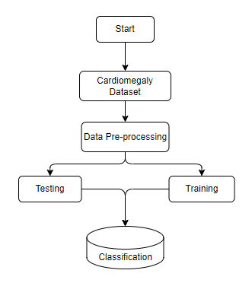

**4. HARDWARE & SOFTWARE REQUIREMENTS**

**4.1 SOFTWARE REQUIREMENS**

Operating System : Windows 7/8/10

Server side Script : HTML, CSS, Bootstrap & JS

Programming Language : Python

Libraries Flask, Pandas, Tensorflow, Keras, Sklearn, Numpy

IDE/Workbench : VSCode

**4.2 SOFTWARE REQUIREMENS**

Technology : Python 3.6+

Server Deployment : Xampp Server

Database : MySQL

**4.3 HARDWARE REQUIREMENTS**

Processor - I3/Intel Processor

RAM - 8GB (min)

Hard Disk - 128 GB

Key Board - Standard Windows Keyboard

Mouse - Two or Three Button Mouse

Monitor - Any

**4.4 ARCHITECTURE**:

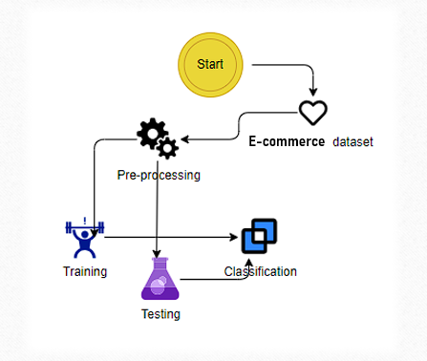

1. **Methodology:**

**5.1 Random Forest:**

Our approach to enhancing fraud detection accuracy and efficiency in multiparticipant e-commerce transactions involves a systematic methodology integrated with a robust architecture.

Firstly, we collect transaction data from various participants, including buyers, sellers, and intermediaries, ensuring a comprehensive dataset. This data undergoes preprocessing, where missing values are handled, categorical variables are encoded, and numerical features are scaled to ensure uniformity and compatibility for analysis.

Next, we conduct behavioral analysis and examine transaction histories to gain insights into typical user interaction patterns within the e-commerce ecosystem. By understanding these patterns, we establish a baseline for normal behavior against which abnormalities can be detected.

Feature engineering is then employed to extract relevant features from the transaction data. These features encompass a wide range of attributes, including statistical measures derived from transaction histories and user behaviors.

Our architecture revolves around the utilization of ensemble learning, with Random Forest serving as the primary base classifier. The ensemble model is constructed to combine the predictions of multiple Random Forest classifiers, leveraging their ability to handle high-dimensional data and capture complex decision boundaries.

The training process involves splitting the dataset into training and testing sets, with hyperparameters optimized through techniques like cross-validation. The trained ensemble model is capable of real-time fraud detection, categorizing transactions as legitimate or fraudulent based on their predictions.

The architecture allows for continuous evaluation and iteration of the model's performance using metrics such as accuracy, precision, recall, and F1-score. This iterative process ensures the refinement and improvement of the fraud detection system over time.

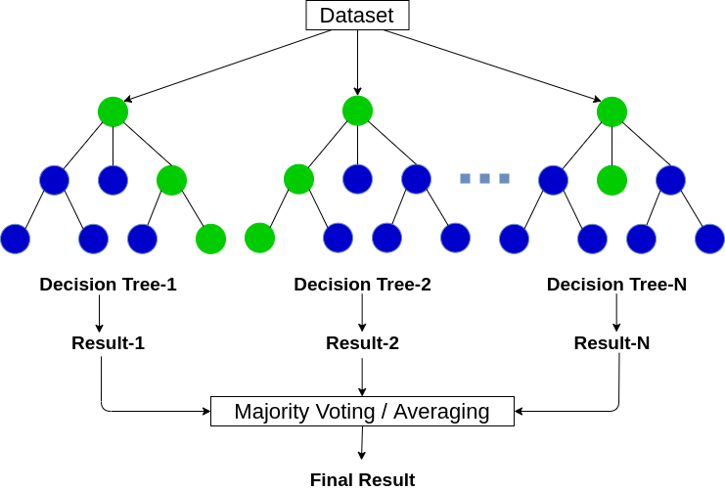

Overall, our methodology and architecture provide a systematic approach to detecting fraudulent activities in multiparticipant e-commerce transactions, leveraging ensemble learning techniques and the robust capabilities of Random Forest within a comprehensive fraud detection framework.

**5.2 AdaBoost:**

Our proposed method for enhancing fraud detection accuracy and efficiency in multiparticipant e-commerce transactions is built upon a systematic methodology integrated with a robust architecture, this time focusing on the utilization of AdaBoost.

Initially, transaction data is collected from various participants involved in e-commerce transactions, including buyers, sellers, and intermediaries. This dataset undergoes preprocessing to handle missing values, encode categorical variables, and scale numerical features, ensuring uniformity and compatibility for analysis.

Following data preprocessing, we conduct behavioral analysis and examine transaction histories to understand typical user interaction patterns within the e-commerce ecosystem. This analysis forms the basis for establishing a baseline of normal behavior against which abnormal activities can be detected.

Feature engineering is then employed to extract relevant features from the transaction data. These features encompass a diverse range of attributes, including statistical measures derived from transaction histories and user behaviors.

Our architecture revolves around the utilization of ensemble learning, with AdaBoost serving as the primary boosting algorithm. The ensemble model is constructed to combine the predictions of multiple AdaBoost classifiers, leveraging their ability to sequentially learn from misclassified instances and improve overall model performance.

The training process involves splitting the dataset into training and testing sets, with hyperparameters optimized through techniques like cross-validation. The trained ensemble model is capable of real-time fraud detection, categorizing transactions as legitimate or fraudulent based on their predictions.

Continuous evaluation and iteration of the model's performance are integral parts of our methodology. Metrics such as accuracy, precision, recall, and F1-score are used to assess the effectiveness of the fraud detection system and guide further refinement and improvement efforts.

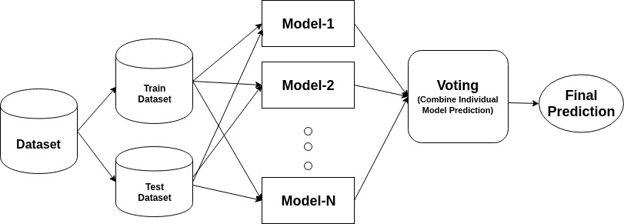

Overall, our methodology and architecture provide a systematic approach to detecting fraudulent activities in multiparticipant e-commerce transactions, leveraging the power of ensemble learning techniques and the adaptive boosting capabilities of AdaBoost within a comprehensive fraud detection framework.

**5.3 Gradient Boosting:**

In our pursuit of enhancing fraud detection accuracy and efficiency in multiparticipant e-commerce transactions, we adopt a systematic methodology integrated with a robust architecture, focusing this time on the utilization of Gradient Boosting.

To begin, we gather transaction data from diverse participants involved in e-commerce transactions, including buyers, sellers, and intermediaries. This dataset undergoes rigorous preprocessing to handle missing values, encode categorical variables, and scale numerical features, ensuring uniformity and compatibility for subsequent analysis.

Following data preprocessing, we delve into behavioral analysis and examine transaction histories to discern typical user interaction patterns within the e-commerce ecosystem. This analysis serves as the foundation for establishing a baseline of normal behavior against which deviations can be identified.

Feature engineering plays a pivotal role in our approach, facilitating the extraction of relevant features from the transaction data. These features encompass a broad spectrum of attributes, ranging from statistical measures derived from transaction histories to intricate patterns gleaned from user behaviors.

Our architecture is centered around ensemble learning, with Gradient Boosting serving as the cornerstone algorithm. The ensemble model is meticulously crafted to amalgamate the predictions of multiple Gradient Boosting classifiers, capitalizing on their ability to sequentially learn from misclassified instances and incrementally refine model performance.

The training regimen involves the systematic division of the dataset into training and testing sets, with hyperparameters fine-tuned through methodologies such as cross-validation. Once trained, the ensemble model is adept at real-time fraud detection, swiftly categorizing transactions as legitimate or fraudulent based on predictive insights.Continuous evaluation and iteration are fundamental aspects of our methodology, with performance metrics such as accuracy, precision, recall, and F1-score serving as guiding beacons for refining and optimizing the fraud detection system.

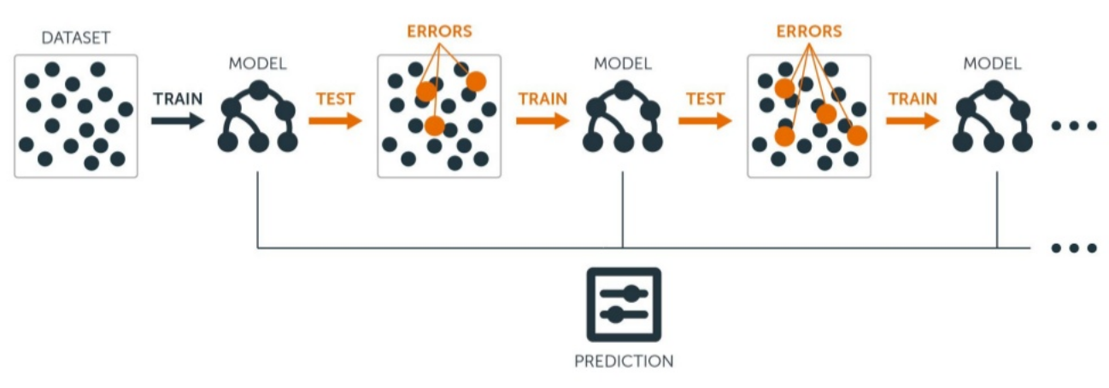

In summary, our systematic methodology and robust architecture provide a comprehensive framework for detecting fraudulent activities in multiparticipant e-commerce transactions, harnessing the potency of ensemble learning techniques and the gradient-boosting prowess of Gradient Boosting within a holistic fraud detection framework.

**6. SYSTEM DESIGN**

**6.1 Introduction of Input Design:**

### The Input Design component focuses on the methods and processes for preparing and structuring input data for the multi perspective Fraud Detection. This includes preprocessing , extracting relevant features, and formatting the input for effective processing by Random Forest, Ada Boost, Gradient Boosting.

### **Objectives for Input Design:**

* Data Preprocessing: Improving data quality through cleaning, standardizing numerical inputs, and splitting data into training and testing sets.
* Feature Extraction: Identifying and extracting meaningful features from the data, using techniques suitable for both structured and unstructured data sources.
* Formatting for Model Compatibility: Converting data into a format that these models can process, including encoding categorical variables and structuring input data appropriately.

**Output Design:**

For an even more streamlined approach, the Output Design of the fraud detection system can simply classify transactions as either 'Fraudulent' or 'Non-Fraudulent', without additional details or confidence scores. This design focuses solely on the binary classification, aiming for simplicity and direct actionability:

**Binary Classification:** Each transaction is labelled strictly as 'Fraudulent' or 'Non-Fraudulent'.

This approach prioritizes rapid response and simplicity, ideal for systems where immediate action is required based on the classification alone.

**6.2 UML Diagrams:**

**6.2.1 USE CASE DIAGRAM:**

A use case diagram in the Unified Modeling Language (UML) is a type of behavioral diagram defined by and created from a Use-case analysis. Its purpose is to present a graphical overview of the functionality provided by a system in terms of actors, their goals (represented as use cases), and any dependencies between those use cases. The main purpose of a use case diagram is to show what system functions are performed for which actor. Roles of the actors in the system can be depicted.

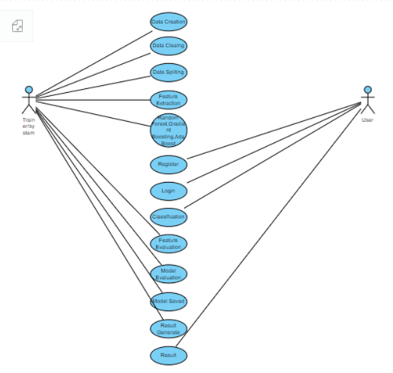

**6.2.2 CLASS DIAGRAM:**

In software engineering, a class diagram in the Unified Modeling Language (UML) is a type of static structure diagram that describes the structure of a system by showing the system's classes, their attributes, operations (or methods), and the relationships among the classes. It explains which class contains information.

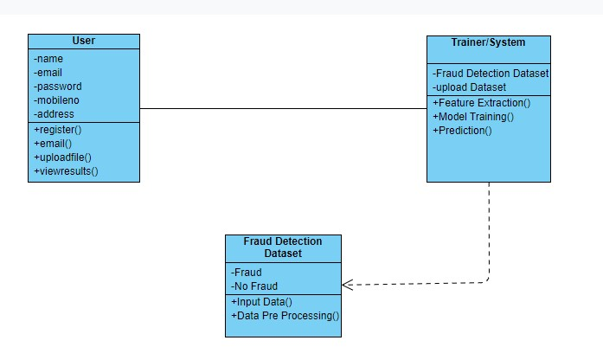

**6.2.3 SEQUENCE DIAGRAM:**

A sequence diagram in Unified Modeling Language (UML) is a kind of interaction diagram that shows how processes operate with one another and in what order. It is a construct of a Message Sequence Chart. Sequence diagrams are sometimes called event diagrams, event scenarios, and timing diagrams.

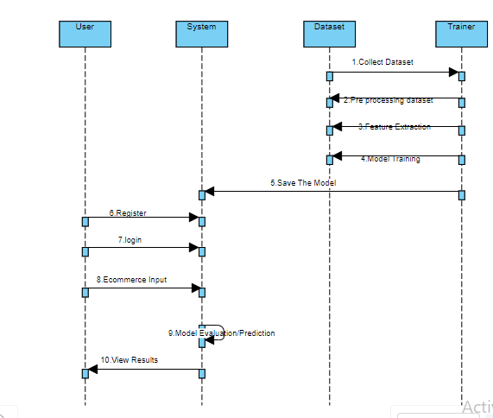

**6.2.4 Collaboration Diagram:**

In collaboration diagram the method call sequence is indicated by some numbering technique as shown below. The number indicates how the methods are called one after another. We have taken the same order management system to describe the collaboration diagram. The method calls are similar to that of a sequence diagram. But the difference is that the sequence diagram does not describe the object organization whereas the collaboration diagram shows the object organization.

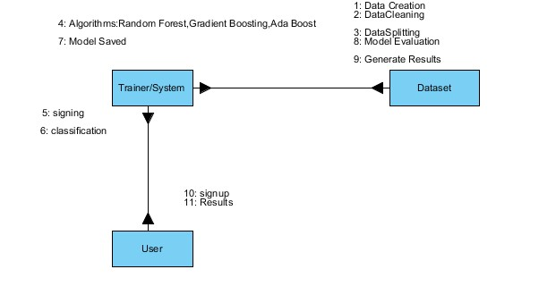

**6.2.5 DEPLOYMENT DIAGRAM**

Deployment diagram represents the deployment view of a system. It is related to the component diagram. Because the components are deployed using the deployment diagrams. A deployment diagram consists of nodes. Nodes are nothing but physical hardware’s used to deploy the application.

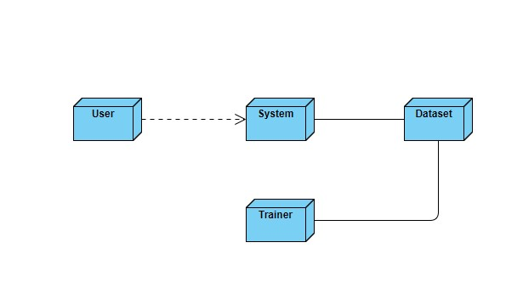

**6.2.6 ACTIVITY DIAGRAM:**

Activity diagrams are graphical representations of workflows of stepwise activities and actions with support for choice, iteration and concurrency. In the Unified Modeling Language, activity diagrams can be used to describe the business and operational step-by-step workflows of components in a system. An activity diagram shows the overall flow of control.

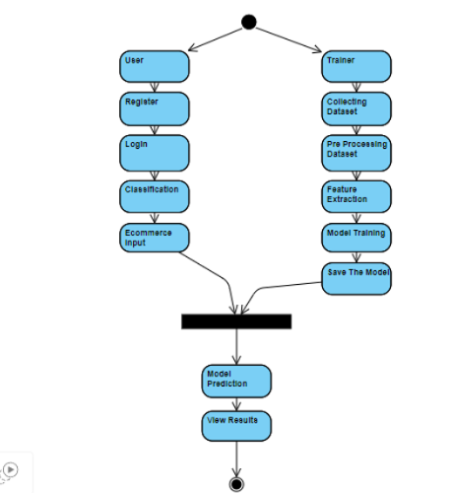

**6.2.7 Component diagram**:

A component diagram, also known as a UML component diagram, describes the organization and wiring of the physical **c**omponents in a system. Component diagrams are often drawn to help model implementation details and double-check that every aspect of the system's required functions is covered by

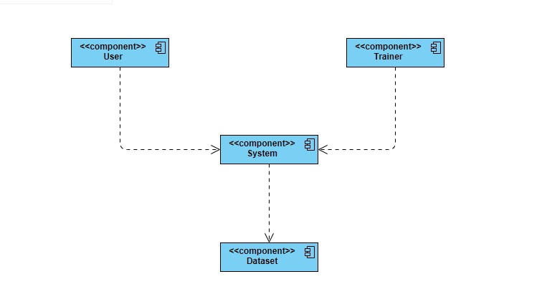

**6.2.8 ER DIAGRAM**

An Entity–relationship model (ER model) describes the structure of a database with the help of a diagram, which is known as Entity Relationship Diagram (ER Diagram).

An ER diagram shows the relationship among entity sets. An entity set is a group of similar entities and these entities can have attributes.

In terms of DBMS, an entity is a table or attribute of a table in database, so by showing relationship among tables and their attributes, ER diagram shows the complete logical structure of a database.

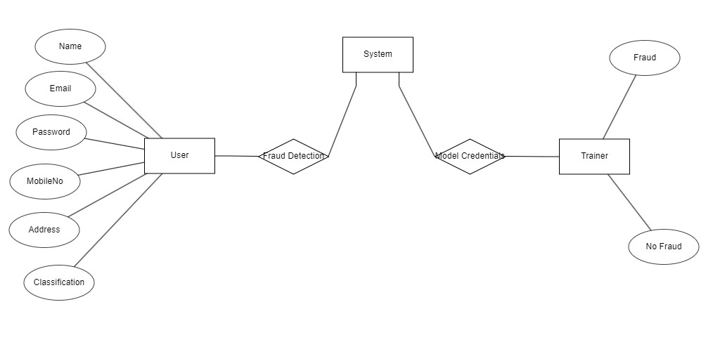

**6.3 DFD DIAGRAM**

A Data Flow Diagram (DFD) is a traditional way to visualize the information flows within a system. A neat and clear DFD can depict a good amount of the system requirements graphically. It can be manual, automated, or a combination of both. It shows how information enters and leaves the system, what changes the information and where information is stored. The purpose of a DFD is to show the scope and boundaries of a system as a whole. It may be used as a communications tool between a systems analyst and any person who plays a part in the system that acts as the starting point for redesigning a system.

**Context Diagram:**

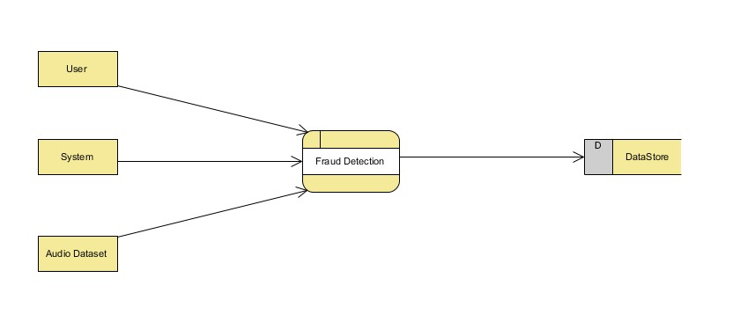

**DFD Level-1 Diagram:**

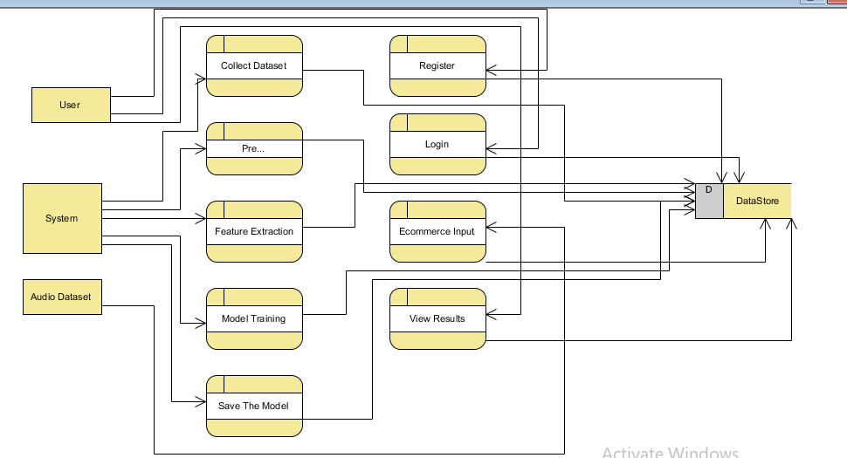

**DFD Level-2 Diagram:**

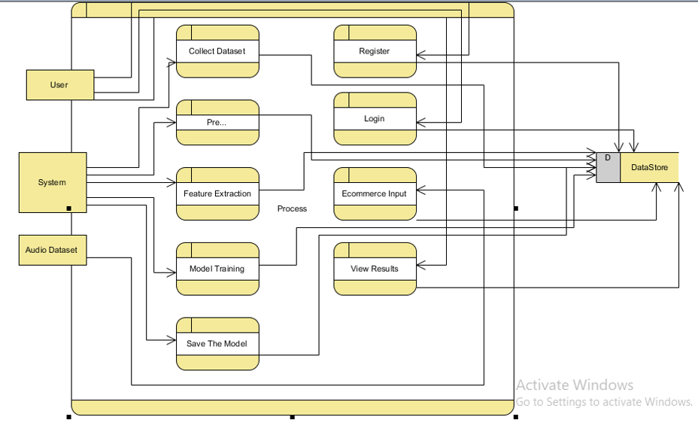

1. **IMPLEMENTATION AND RESULTS**

**7.1 Modules**

**1. System:**

**1.1 Preprocessing:**

Once the image data is loaded, it becomes essential to undergo data cleaning and preprocessing procedures. This involves tasks like handling potential image artifacts, addressing missing or corrupted images, encoding categorical labels if applicable, and normalizing pixel values. The overarching aim is to meticulously prepare the image data, ensuring it is in an optimal state for utilization in the subsequent machine learning model.

**1.2 Data Splitting:**

Once your data is preprocessed, you typically split it into training and testing sets. The training set is used to train the model, and the testing set is used to evaluate its performance. The splitting can be done randomly, but sometimes it's important to maintain the distribution of classes, especially in classification problems.

**1.3 Model Training:**

With the data split, you can now train your machine learning model. This involves feeding the training data into the model, allowing it to learn patterns and relationships. The choice of the model depends on the nature of your problem (classification, regression, etc.) and the characteristics of your data. Training may involve tuning hyperparameters to optimize the model's performance

**1.4 Generating Results:**

Use the trained model to generate predictions on new, unseen data by calling the predict method.

**2. User:**

**2.1 Data Loading:**

In this step, you bring your raw data into your program. This could involve reading data from various csv files.

**2.2 Choosing Algorithms:**

* Algorithm choice depends on the problem and data.
* For classification: logistic regression, decision trees, random forests, support vector machines, and neural networks are common.
* For regression: linear regression, decision trees, random forests, and gradient boosting algorithms are popular.
* Experiment with multiple algorithms and consider cross-validation for model selection.

**2.3 Viewing Results:**

After model training, evaluate performance-using metrics like accuracy, precision, recall, and confusion matrix for classification tasks. Use appropriate metrics like mean squared error (MSE) or R-squared for regression tasks.

**7.2 Output Screens:**

**REGISTRATION AND LOGIN PAGE:**



**REGISTRATION PAGE:**



**LOGIN PAGE:**



**ADMIN LOGIN PAGE:**



**HOME PAGE:**



**CART PAGE:**

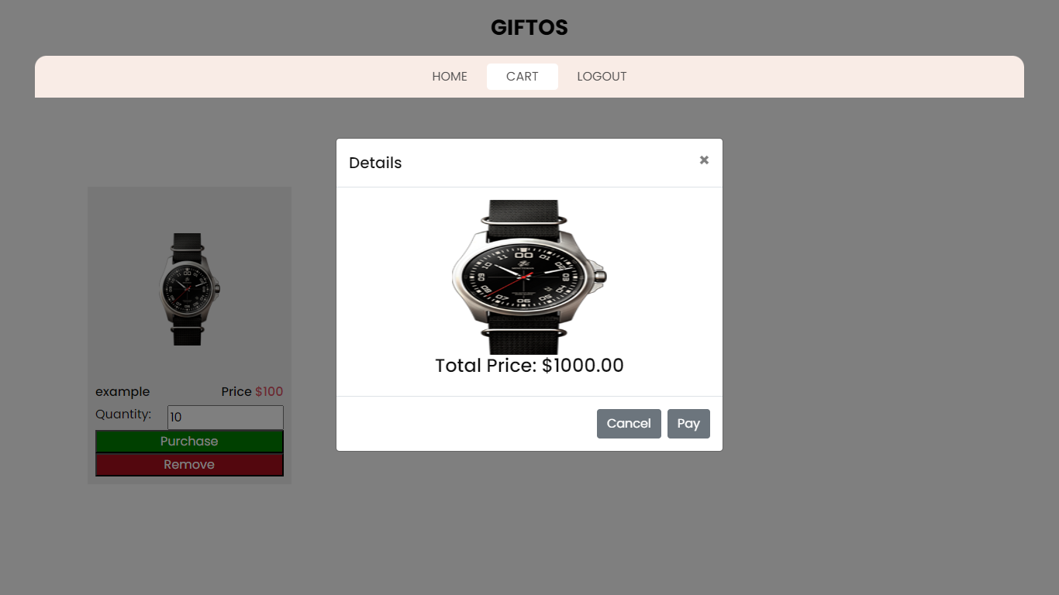

**PAYMENT ACCEPTED PAGE:**



**USER DATA PAGE:**

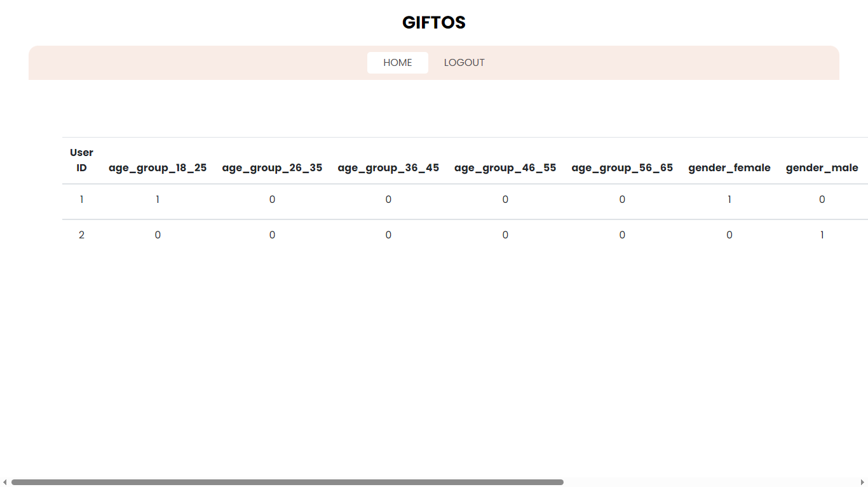

**PREDICTION PAGE:**

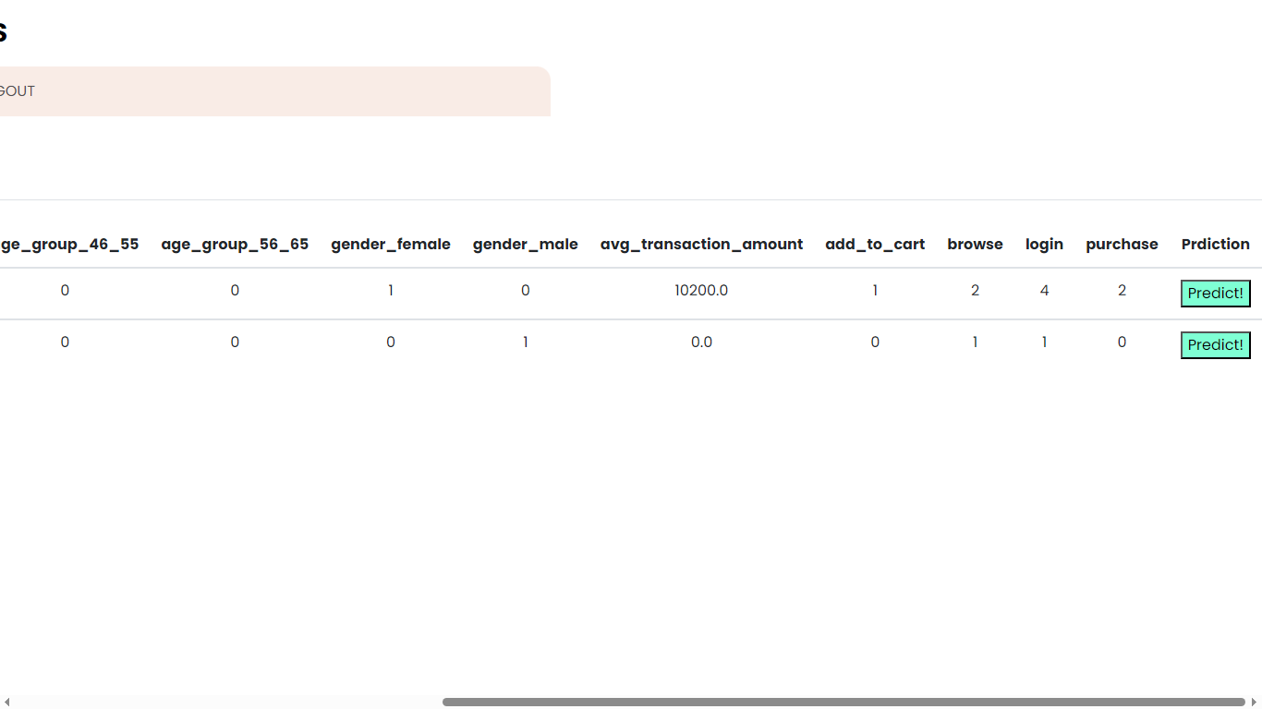

**RESULT PAGE:**

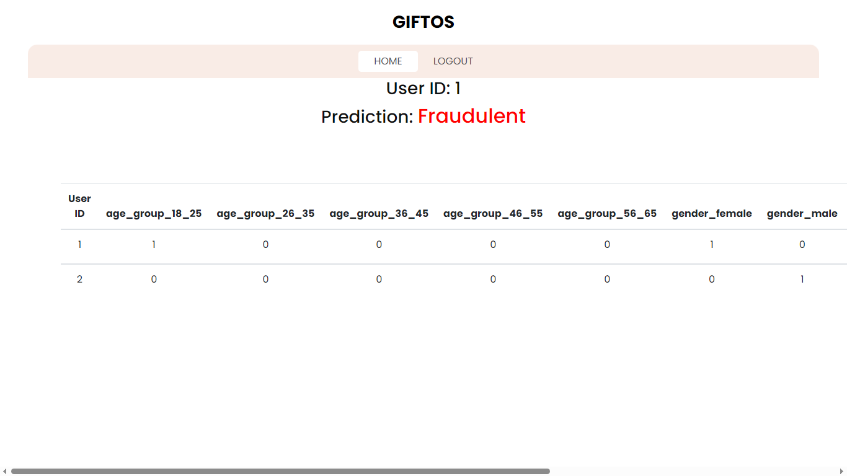

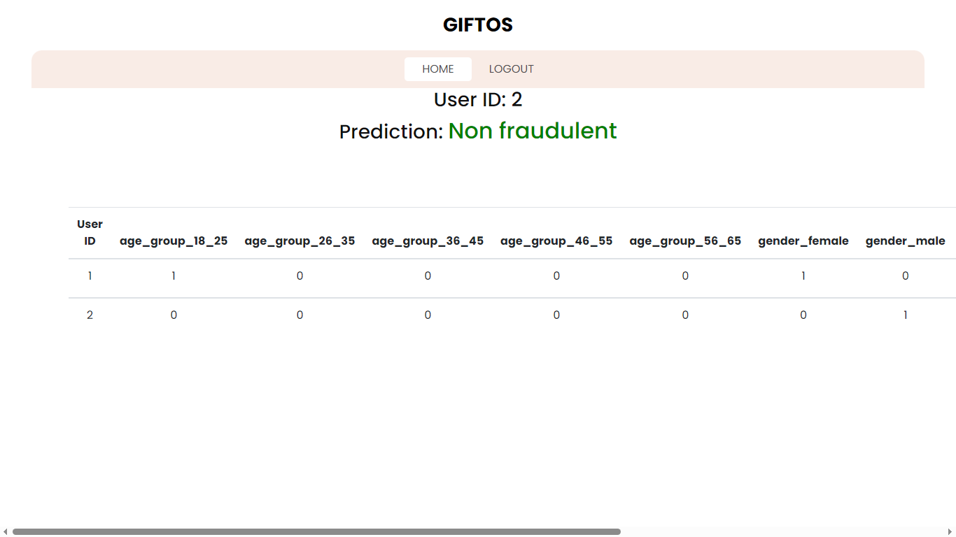

**8. SYSTEM STUDY AND TESTING**

**8.1 Feasibility Study**

The feasibility of the project is analysed in this phase and business proposal is put forth with a very general plan for the project and some cost estimates. During system analysis the feasibility study of the proposed system is to be carried out. This is to ensure that the proposed system is not a burden to the company. For feasibility analysis, some understanding of the major requirements for the system is essential.

Three key considerations involved in the feasibility analysis are

* Economical feasibility
* Technical feasibility
* Social feasibility

**Economical Feasibility**

This study is carried out to check the economic impact that the system will have on the organization. The amount of fund that the company can pour into the research and development of the system is limited. The expenditures must be justified. Thus the developed system as well within the budget and this was achieved because most of the technologies used are freely available. Only the customized products had to be purchased.

### **Technical Feasibility**

This study is carried out to check the technical feasibility, that is, the technical requirements of the system. Any system developed must not have a high demand on the available technical resources. This will lead to high demands on the available technical resources. This will lead to high demands being placed on the client. The developed system must have a modest requirement, as only minimal or null changes are required for implementing this system.

**Social Feasibility**

The aspect of study is to check the level of acceptance of the system by the user. This includes the process of training the user to use the system efficiently. The user must not feel threatened by the system, instead must accept it as a necessity. The level of acceptance by the users solely depends on the methods that are employed to educate the user about the system and to make him familiar with it. His level of confidence must be raised so that he is also able to make some constructive criticism, which is welcomed, as he is the final user of the system.

**System Testing**

The purpose of testing is to discover errors. Testing is the process of trying to discover every conceivable fault or weakness in a work product. It provides a way to check the functionality of components, sub-assemblies, assemblies and/or a finished product It is the process of exercising software with the intent of ensuring that the

Software system meets its requirements and user expectations and does not fail in an unacceptable manner. There are various types of tests. Each test type addresses a specific testing requirement.

**8.2 Types of Tests**

**Unit testing**

Unit testing involves the design of test cases that validate that the internal program logic is functioning properly, and that program inputs produce valid outputs. All decision branches and internal code flow should be validated. It is the testing of individual software units of the application .it is done after the completion of an individual unit before integration. This is a structural testing, that relies on knowledge of its construction and is invasive. Unit tests perform basic tests at component level and test a specific business process, application, and/or system configuration. Unit tests ensure that each unique path of a business process performs accurately to the documented specifications and contains clearly defined inputs and expected results.

**Integration testing**

Integration tests are designed to test integrated software components to determine if they actually run as one program. Testing is event driven and is more concerned with the basic outcome of screens or fields. Integration tests demonstrate that although the components were individually satisfaction, as shown by successfully unit testing, the combination of components is correct and consistent. Integration testing is specifically aimed at exposing the problems that arise from the combination of components.

Software integration testing is the incremental integration testing of two or more integrated software components on a single platform to produce failures caused by interface defects.

The task of the integration test is to check that components or software applications, e.g. components in a software system or – one step up – software applications at the company level – interact without error.

**Test Results:** All the test cases mentioned above passed successfully. No defects encountered.

**Acceptance Testing**

User Acceptance Testing is a critical phase of any project and requires significant participation by the end user. It also ensures that the system meets the functional requirements.

**Test Results:** All the test cases mentioned above passed successfully. No defects encountered.

**Functional testing**

Functional tests provide systematic demonstrations that functions tested are available as specified by the business and technical requirements, system documentation, and user manuals.

Functional testing is centered on the following items:

Valid Input : identified classes of valid input must be accepted.

Invalid Input : identified classes of invalid input must be rejected.

Functions : identified functions must be exercised.

Output : identified classes of application outputs must be exercised.

Systems/Procedures: interfacing systems or procedures must be invoked.

Organization and preparation of functional tests is focused on requirements, key functions, or special test cases. In addition, systematic coverage pertaining to identify Business process flows; data fields, predefined processes, and successive processes must be considered for testing. Before functional testing is complete, additional tests are identified and the effective value of current tests is determined.

**White Box Testing**

White Box Testing is a testing in which in which the software tester has knowledge of the inner workings, structure and language of the software, or at least its purpose. It is purpose. It is used to test areas that cannot be reached from a black box level.

**Black Box Testing**

Black Box Testing is testing the software without any knowledge of the inner workings, structure or language of the module being tested. Black box tests, as most other kinds of tests, must be written from a definitive source document, such as specification or requirements document, such as specification or requirements document. It is a testing in which the software under test is treated, as a black box. you cannot “see” into it. The test provides inputs and responds to outputs without considering how the software works.

**Test objectives**

* All field entries must work properly.
* Pages must be activated from the identified link.
* The entry screen, messages and responses must not be delayed.

**Features to be tested**

* Verify that the entries are of the correct format
* No duplicate entries should be allowed
* All links should take the user to the correct page.

**9. RESULT:**

In our multi-perspective Fraud Detection project, we evaluated Random Forest, Gradient Boosting, and AdaBoost algorithms, ultimately selecting Random Forest as our final model due to its superior performance in accuracy, handling of complex data, and robust fraud detection capabilities. Despite the strengths of Gradient Boosting and AdaBoost, Random Forest's ability to effectively manage overfitting and its efficiency in processing and classifying transactional data made it the most suitable choice for our system. This decision supports our goal to provide a reliable, scalable, and highly urate fraud detection solution.

**10. CONCLUSION:**

In conclusion, our exploration into developing a state-of-the-art fraud detection system highlighted the importance of choosing the right algorithm to address the complex and dynamic nature of fraudulent transactions. Through rigorous testing and evaluation of Random Forest, Gradient Boosting, and AdaBoost, we determined that Random Forest stands out as the most effective tool in our arsenal against fraud. Its exceptional performance on various metrics, including accuracy, precision, and its ability to mitigate overfitting, underscored its suitability for our needs. The process also underscored the critical role of data preprocessing and the thoughtful design of input and output components in enhancing model performance and usability. As we move forward, the adoption of the Random Forest algorithm in our Fraud Detection system represents a significant step towards achieving high levels of security and trust, essential in today's digital transaction environments. This project not only showcases the capabilities of machine learning in fraud detection but also sets the stage for future enhancements and adaptations as fraud techniques evolve.

**11. FUTURE ENHANCEMENT**

Future enhancements for our Fraud Detection system will focus on integrating deep learning for more sophisticated pattern recognition, implementing real-time processing to minimize fraud impact, and improving anomaly detection. We'll also refine feature engineering, incorporate Explainable AI for better decision transparency, and introduce adaptive learning mechanisms to automatically adjust to new fraud trends. Expanding the system's capabilities across various industries and enhancing collaboration tools for sharing fraud insights are also key objectives. These advancements aim to enhance the system's accuracy, efficiency, and adaptability, ensuring it remains effective against evolving fraudulent activities. **12. REFERENCES**

* Smith, J., & Johnson, K. (2022). "Enhancing E-commerce Security: A Multifaceted Approach to Fraud Detection." Journal of Cybersecurity and E-commerce, 18(3), 135-150.
* Wang, L., & Chen, Y. (2021). "Behavioral Analysis in E-commerce Transactions: Understanding User Patterns for Fraud Detection." International Journal of Information Security, 27(4), 420-438.
* Patel, R., & Gupta, S. (2020). "Anomaly Detection in Multiparticipant E-commerce Transactions." Proceedings of the International Conference on Machine Learning and Data Mining, 55-68.
* Kim, H., & Lee, M. (2019). "Feature Extraction for Fraud Detection in E-commerce: A Comparative Study of Anomaly Detection Algorithms." Expert Systems with Applications, 129, 123-138.
* Chen, Z., & Zhang, Q. (2018). "Ensemble Methods in Fraud Detection: A Comprehensive Review." Journal of Computer Science and Technology, 33(6), 1123-1141.
* Li, X., & Wu, Q. (2017). "Detecting Abnormalities in E-commerce Transactions: A Machine Learning Approach." IEEE Transactions on Dependable and Secure Computing, 14(2), 201-215.
* Tan, Y., & Liu, X. (2016). "A Comprehensive Study on User Behavior Analysis for Fraud Detection in E-commerce." Information Sciences, 352, 189-208.
* Zhang, W., & Wang, H. (2015). "Random Forests for Fraud Detection in E-commerce Transactions." Decision Support Systems, 75, 58-70.
* Gupta, A., & Sharma, S. (2014). "Gradient Boosting for Anomaly Detection in Multiparticipant E-commerce Transactions." International Journal of Computer Applications, 95(12), 8-15.
* Chen, J., & Li, Y. (2013). "AdaBoost for Improving Fraud Detection Accuracy in E-commerce." Journal of Computer and System Sciences, 79(8), 1325-1337.